### Project 2: Understanding Cache Memories

Student ID: 518030990025

Name: Eduardo Wang Zheng

E-mail: eduardo@sjtu.edu.cn

1. Introduction

This project is divided into two parts. Part A and B.

In part A, I write a cache simulator in **csim.c,** which can simulate the hit, miss and evictions of cache in a series of data access. When the evictions are needed, I use LRU replacement strategy to choose the victim.

In part B, I write a function to realize matrix transpose in **trans.c** with the goal of minimizing the cache misses. Matrix transpose is defined as follow: for a given matrix A[N][M], matrix B[M][N] is obtained, so that for any 0 < = i < n, 0 < = j < m, there is B [j] [i] = A [i] [j],

1. Experiments
   1. Part A
      1. Analysis

I divide the task into three steps:

1. Declare cache structure and implement various operations
2. Deal with data input. It can be divided into two stages: one is command line input analysis, the other is test data input. So I use function ***getopt()*** and ***fscanf()*** to process the two stages separately.
3. Simulate the behavior of cache. I first think about how cache behaves:

1.The input data specifies the address register to be accessed. (Already done in the previous step)

2. Analyze the input address and determine whether it is hit. The purpose of address analysis is to get the specified number of way-**s** and the corresponding **tag** value.

3. If hit, increment hits , and updates the LRU value. If it not, increment misses, then judge whether it needs eviction and update the LRU value.

* + 1. Code

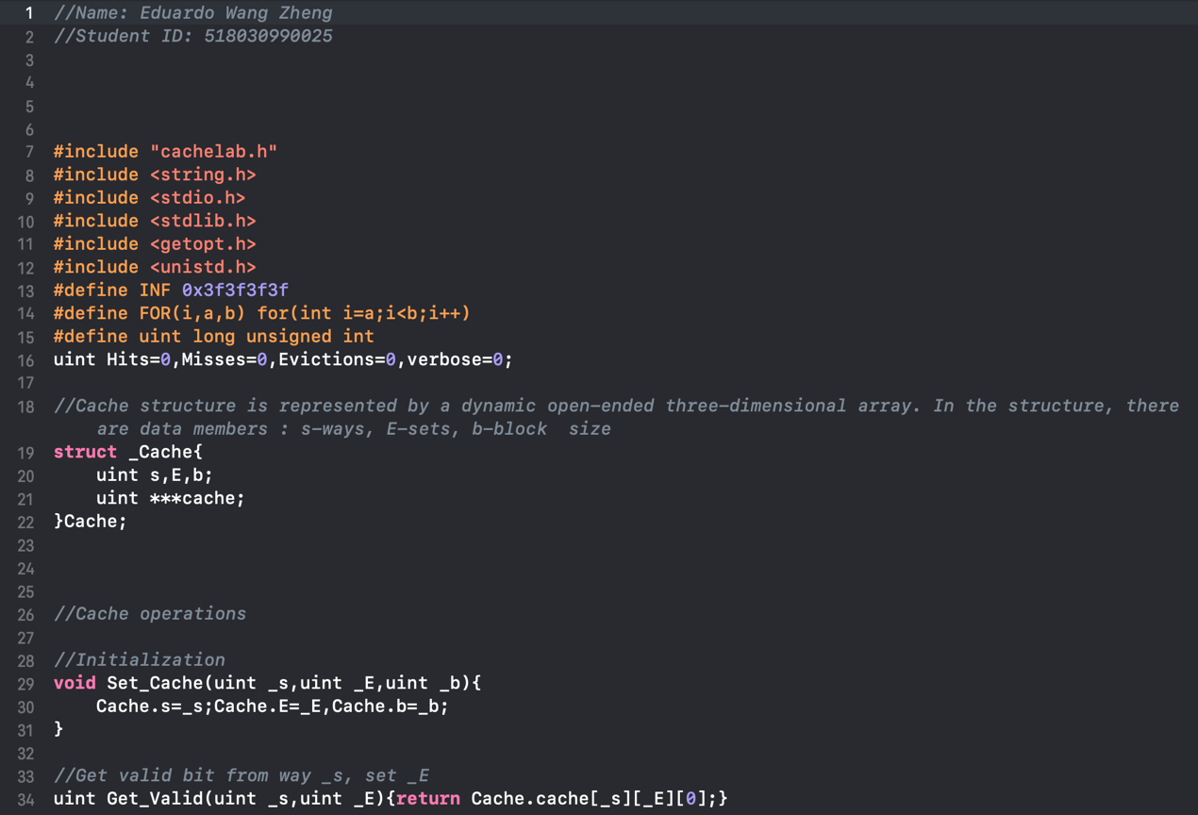

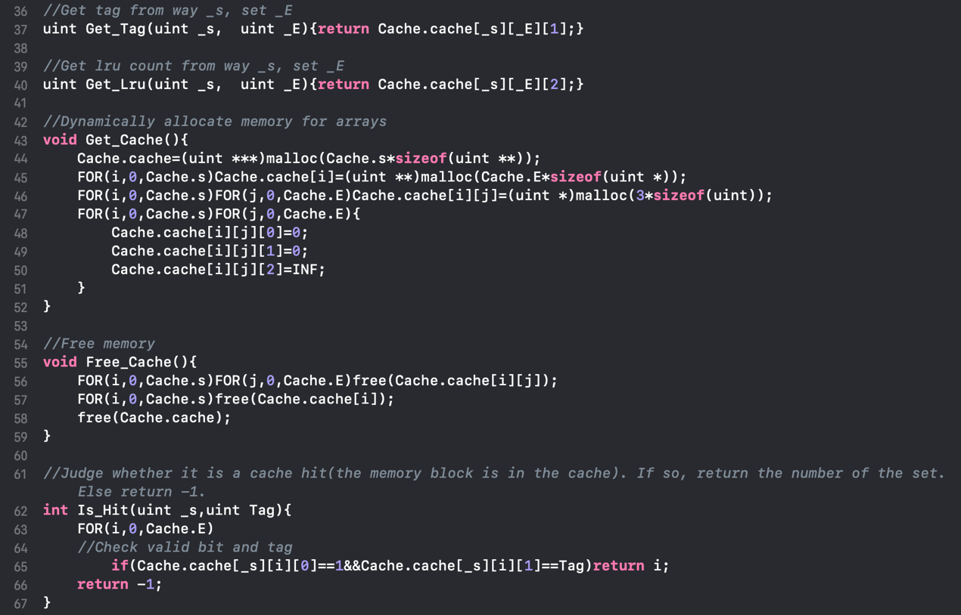

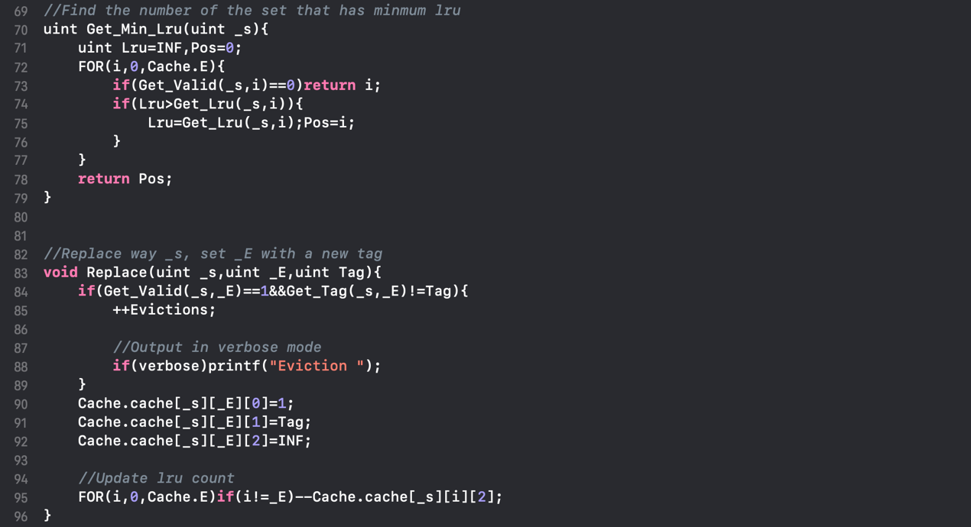

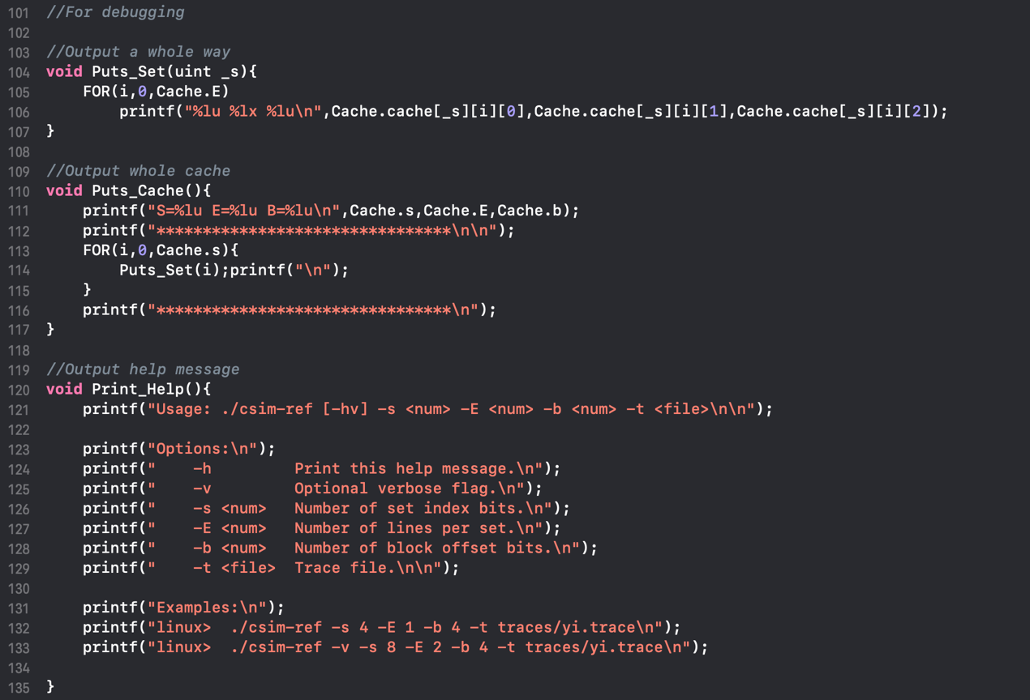

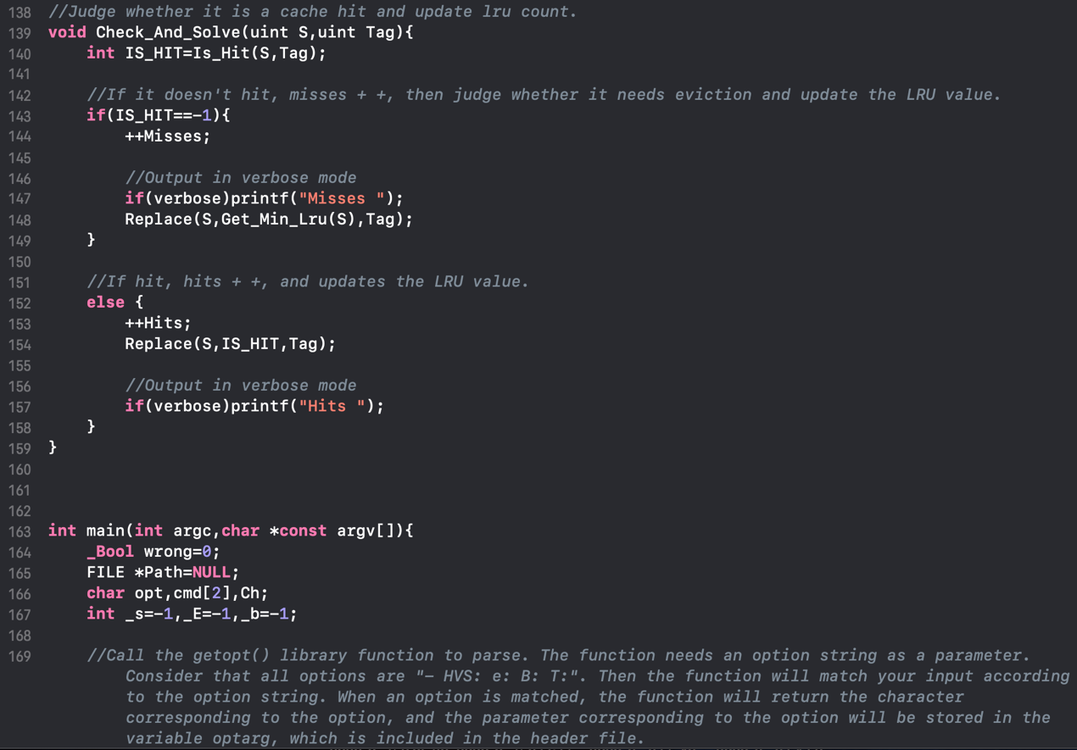

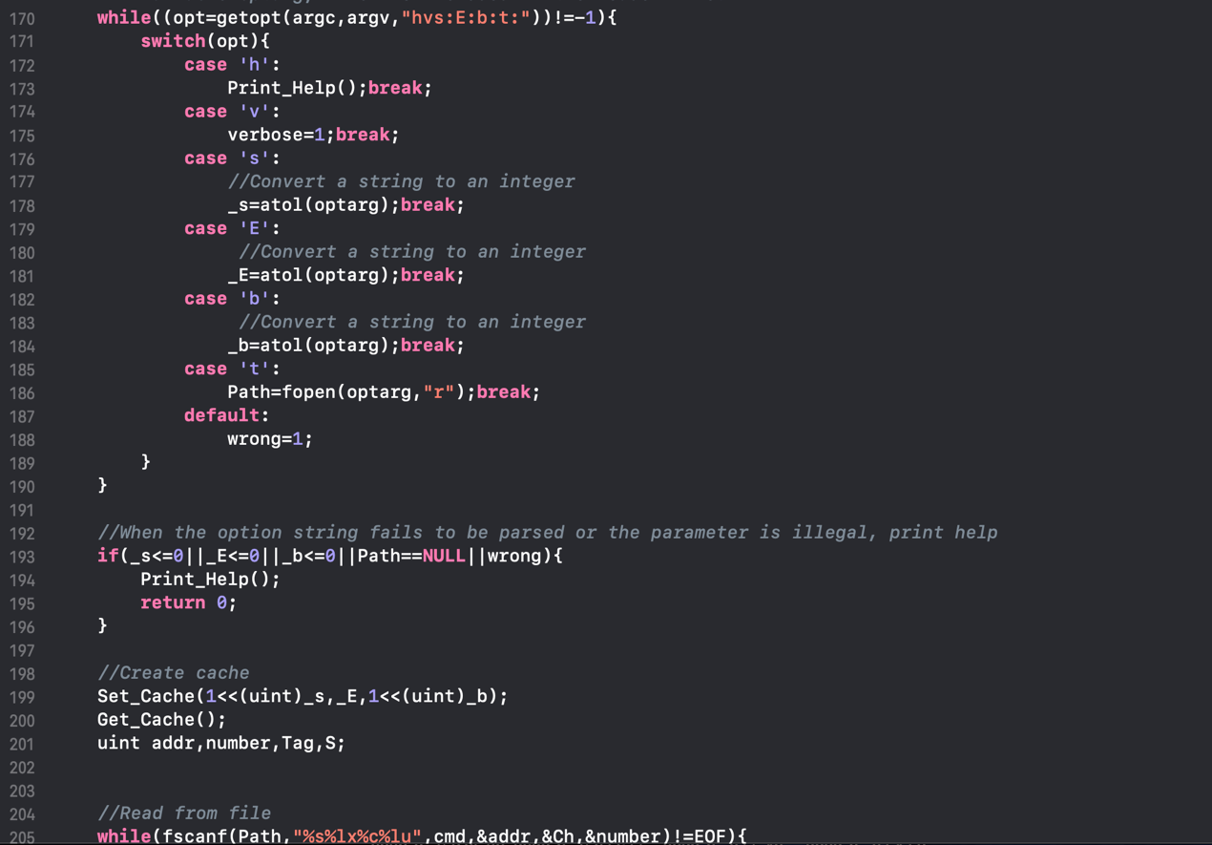

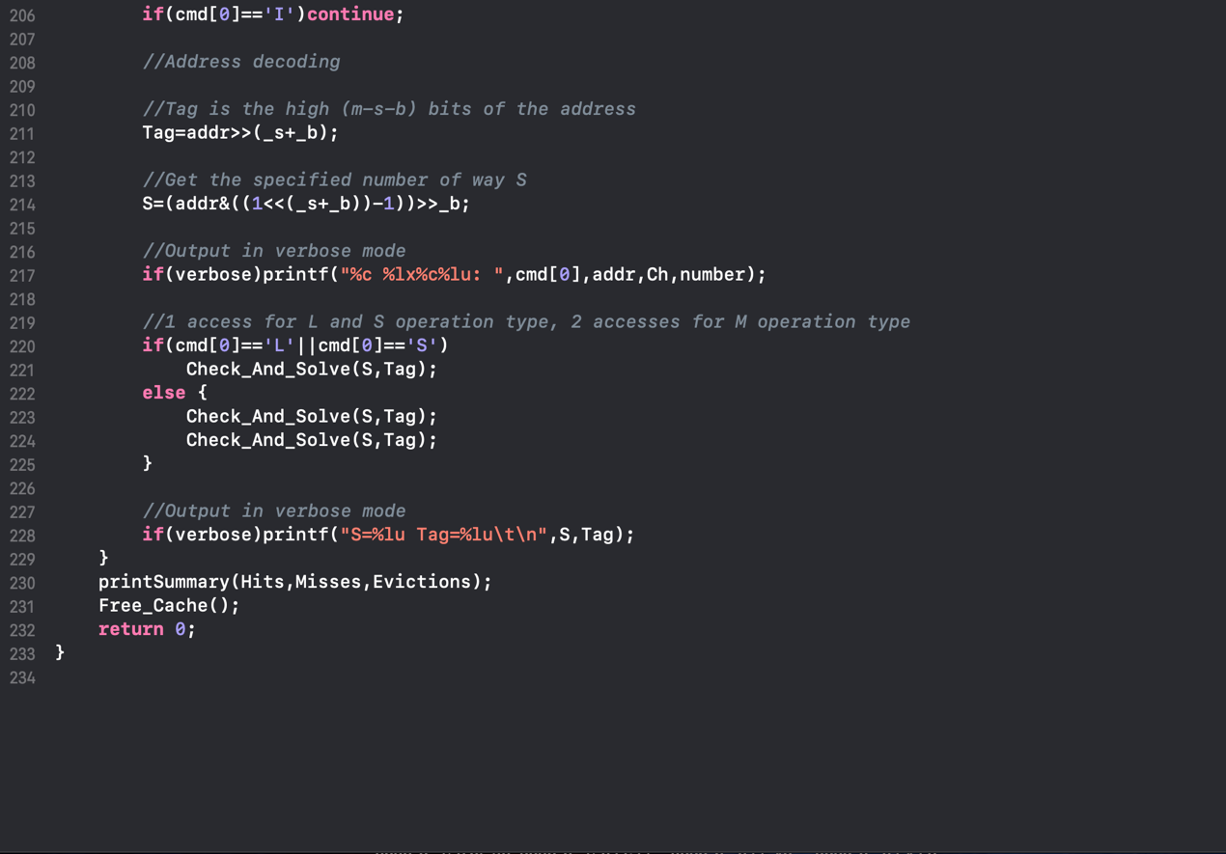

* + 1. Evaluation

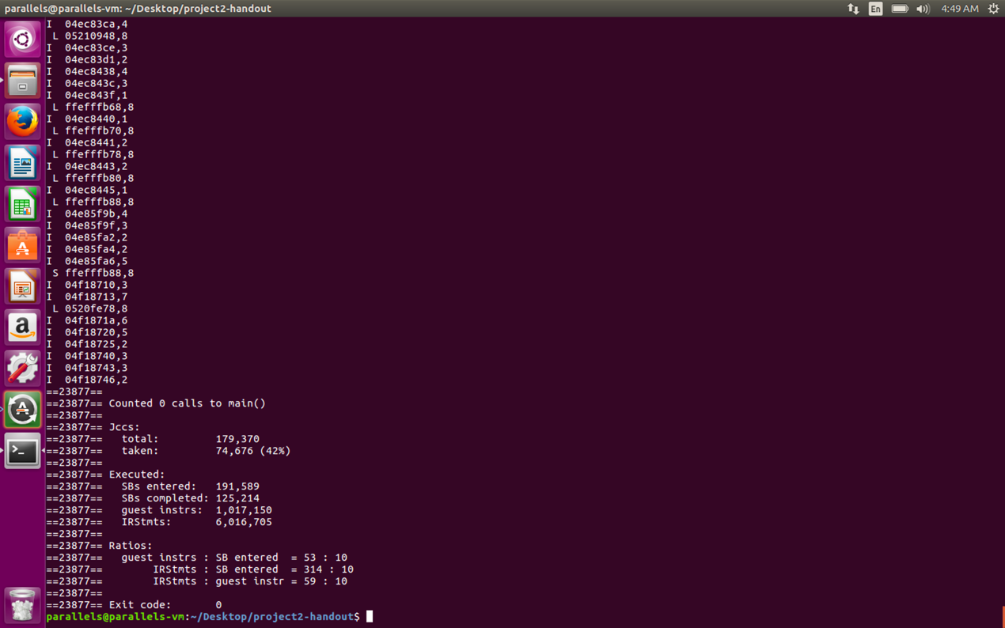

Figure 1 execute **valgrind --log-fd=1 --tool=lackey -v --trace-mem=yes ls-l**

It runs the executable program “**ls -l”**, captures a trace of each of its memory accesses in the order they occur, and prints them on **stdout**.

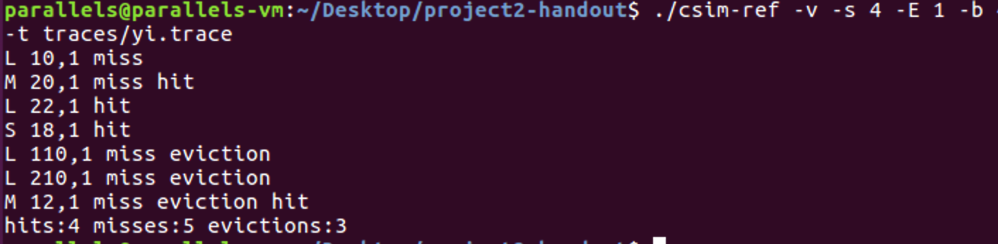

Figure 2 test in verbose mode

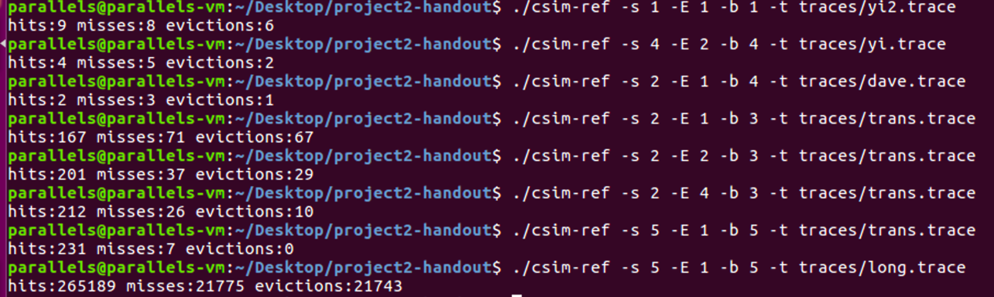

Figure 3 obtain the correct answer for each of test cases

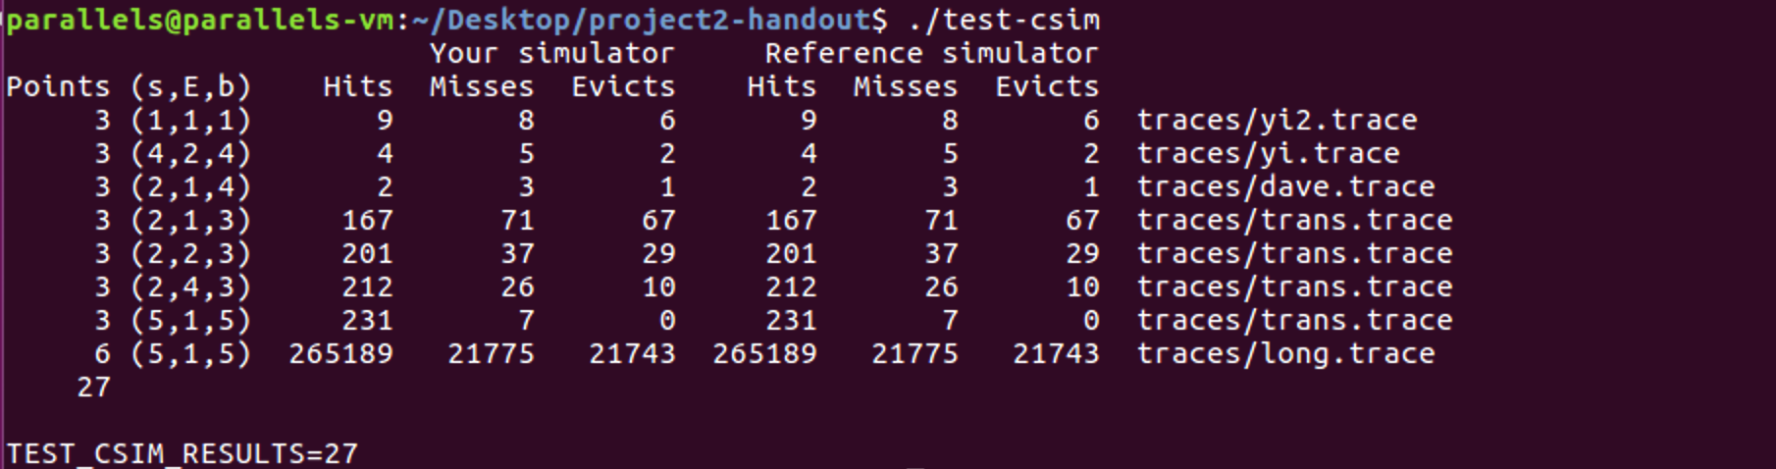

Figure 4 test the correctness of my cache simulator on the reference traces

* 1. Part B
     1. Analysis

1. Consider 4 × 4 matrix

In order to better analyze the cache hit and miss results, we mark the cache block occupied by elements in the array. Because the size of the cache block is 32 bytes, that is, 8 **int** data, the first 8 elements in the array will be in one block, and the last 8 elements in another block, as shown in the following figure:

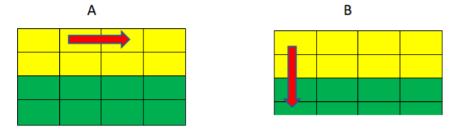

Figure 5 Consider 4 × 4 matrix

The arrows are the order in which two arrays are accessed: array A is accessed by rows, and array B is accessed by columns.

Combined with the tracking results of the simulator and the figure above, the specific analysis is carried out:

1. Array A accesses A [0] [0], it is a miss. Load block 11 into cache.

2. B array accesses B [0] [0], although block 11 mapped by B [0] [0] is in the cache, but the **tag** bits are different, resulting in **conflict miss**, and block 11 corresponding to array B is loaded into the cache again.

3. Array A accesses A [0] [1]. Although block 11 mapped by array A [0] [1] is in the cache, but the **tag** bits are different, resulting in **conflict miss**. Reload block 11 corresponding to array A into the cache.

4. B array accesses B [1] [0]. Although block 11 mapped by B [1] [0] is in the cache, but the **tag** bits are different, resulting in **conflict miss**, and block 11 corresponding to array B is loaded into the cache again.

5. Array A accesses block A [0] [2]. Although block 11 mapped by array A [0] [2] is in the cache, but the **tag** bits are different, resulting in **conflict miss**. Reload block 11 corresponding to array A into the cache.

6. When B array accesses B [2] [0], block 12 mapped by B [2] [0] is not in the cache, and it is miss. Load block 12 corresponding to array B into the cache.

7. Array A accesses A [0] [3], and block 11 mapped by A [0] [3] is in the cache, and the **tag** bits are the same, so it is hit.

8. B array accesses B [3] [0], and block 12 mapped by B [3] [0] is in the cache, and the **tag** bits are the same, so it is hit.

9. Array a accesses A [1] [0], and block 11 mapped by A [1] [0] is in the cache, and the **tag** bits are the same, so it is hit.

10. Array B accesses block B [0] [1]. Although block 11 mapped by B [0] [1] is in the cache, the **tag** bits are different, resulting in **conflict miss**. Reload block 11 corresponding to array B into the cache.

11. Array A accesses A [1] [1]. Although block 11 mapped by array A [1] [1] is in the cache, but the **tag** bits are different, resulting in **conflict miss**. Reload block 11 corresponding to array A into the cache.

12. B array accesses B [1] [1], although block 11 mapped by B [1] [1] is in the cache, but the **tag** bits are different, resulting in **conflict miss**, and block 11 corresponding to array B is loaded into the cache again.

13. Array A accesses block A [1] [2]. Although block 11 mapped by array A [1] [2] is in the cache, but the **tag** bits are different, resulting in **conflict miss.** Reload block 11 corresponding to array A into the cache.

14. B array accesses B [2] [1], and block 12 mapped by B [2] [1] is in the cache, and the **tag** bits are the same, so it is hit.

15. Array A accesses A [1] [3], and block 11 mapped by A [1] [3] is in the cache, and the **tag** bits are the same, so it is hit.

16. B array accesses B [3] [1], block 12 mapped by B [3] [1] is in the cache, and the **tag** bits are the same, so it is hit.

The remaining operations can be analyzed in the same way to get a similar process.

**Problem:** From the above analysis, it can be seen that the reason for too many miss is that there are too many **conflict misses** in the process of accessing two arrays, and the reason behind is that the elements with the same subscript in array B and array A will map to the same cache block.

**Solution:** The first eight elements are in the same block, we can directly take out the eight elements, and then the block where the eight elements are no longer needed to access, so we can greatly reduce the number of conflict misses.

1. Consider 32 × 32 matrix

Because each block can store 8 **int** type data, and there are 32 blocks in the cache, for a 32 × 32 matrix, 32 elements in each row occupy 4 cache blocks and each 8 rows will occupy the whole cache.

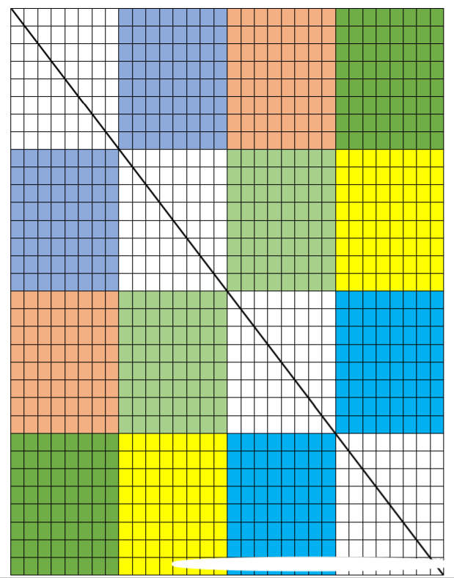

Figure 6 Consider 32 × 32 matrix

In this figure, I mark the region with 8 × 8, because there is no intersection between the groups of the two regions, which means that there will be no conflict miss when the elements are transposed between the two regions. And two areas with the same color indicate that there is a corresponding relationship between the elements of these two areas.

So in order to reduce cache misses, I divide the 32 × 32 matrix into 8 × 8 matrix.

Then consider the area on the diagonal (the uncolored part) above. Since the diagonal elements are still in the same area after transposition, there are likely to be a large number of **conflict misses**, which is very similar to the previous 4 × 4 example. So I also use the optimization method in 4 × 4 example, that is to take all elements in one block at a time, and then we will not access the block after taking them, conflict miss is reduced.

After applying these methods, I obtain the following result:

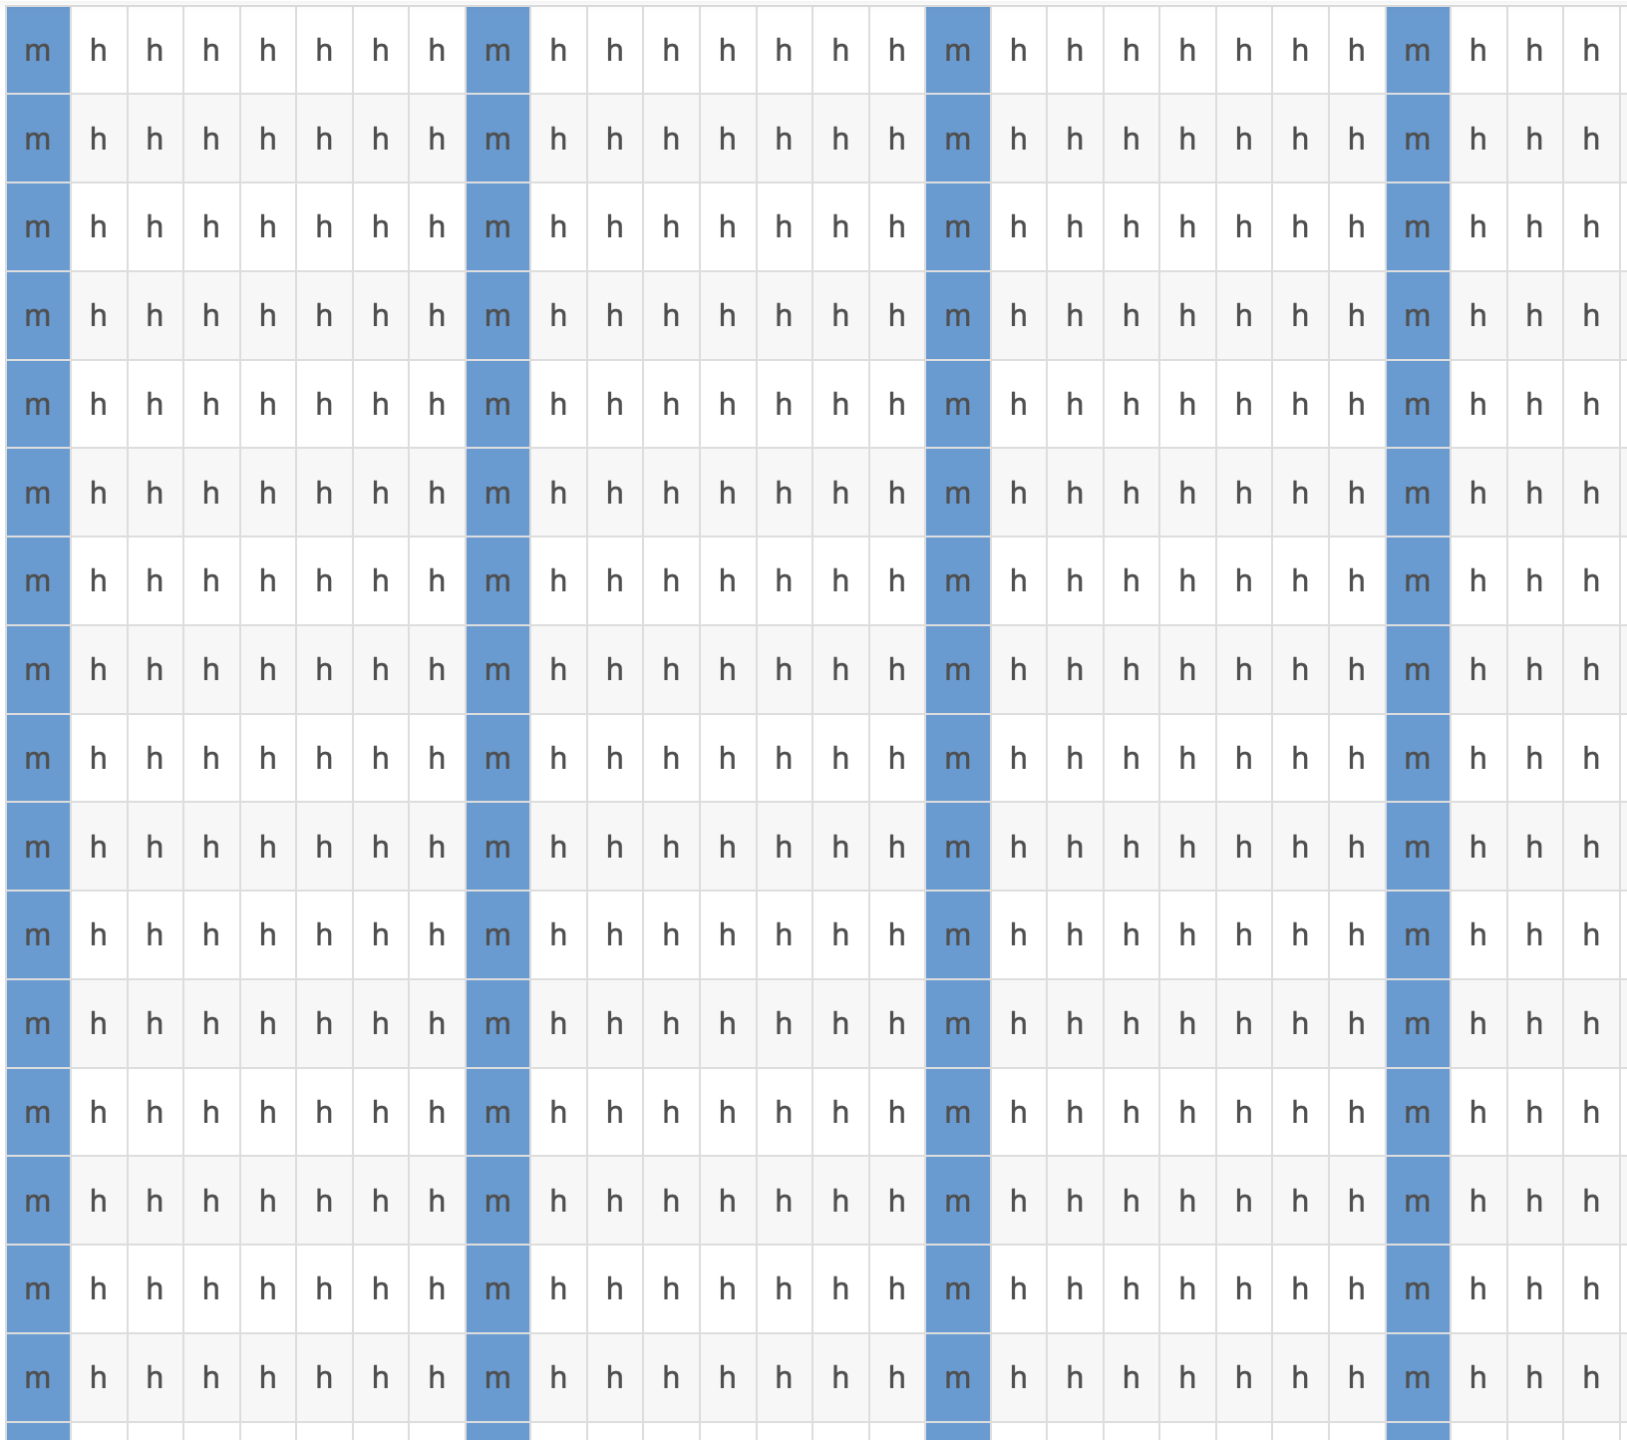

Figure 7 Hit or miss of each element in the array A

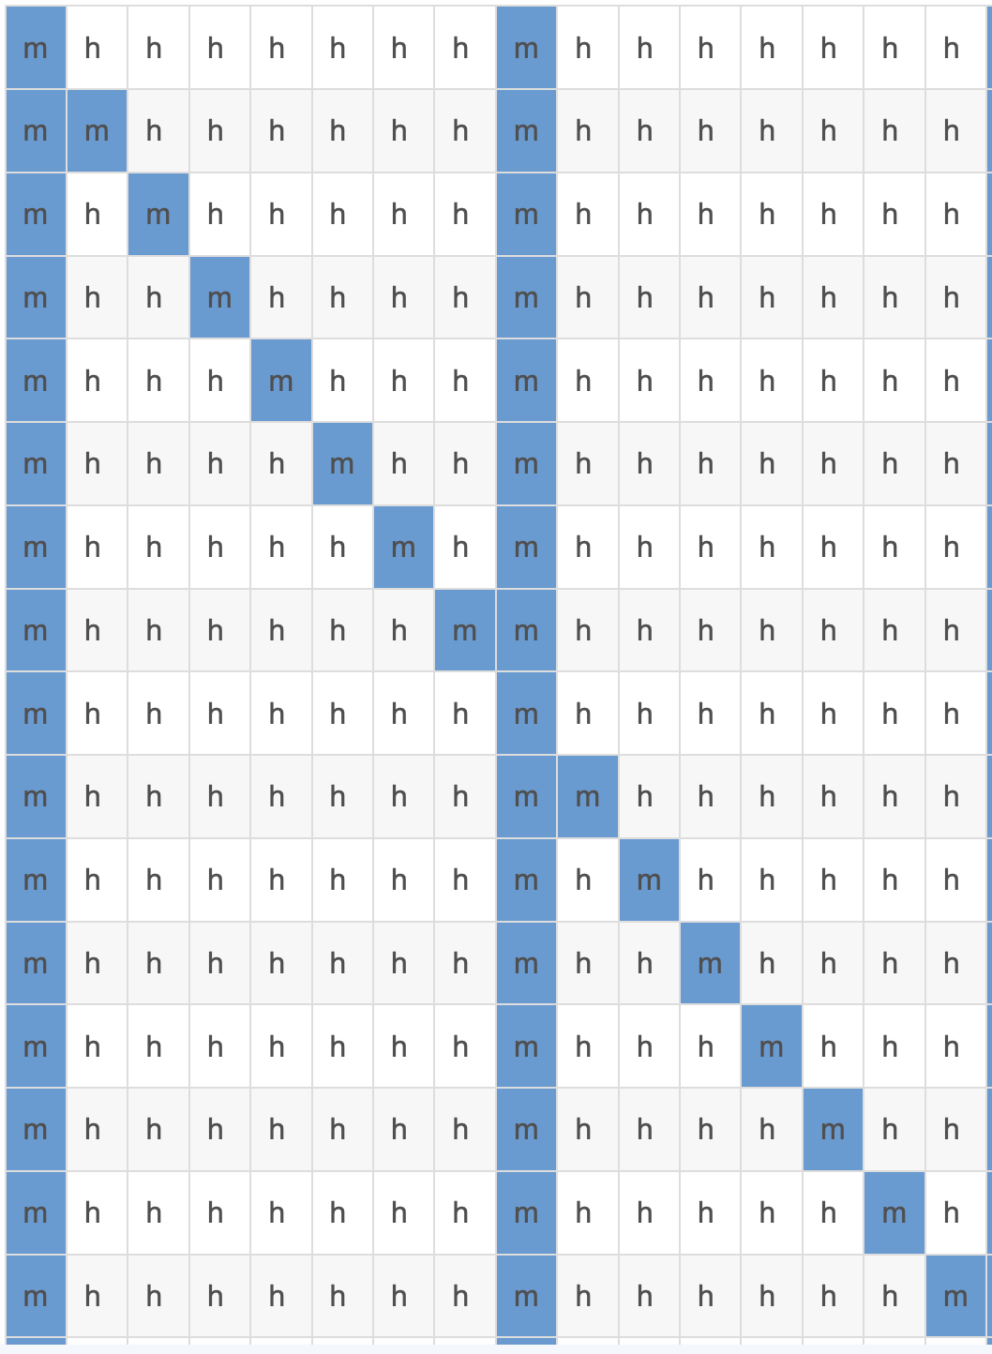

Figure 8 Hit or miss of each element in the array B

It seems that the diagonal can be optimized.

For example, consider the second column of the second row miss. It is because the data in the first row of array A will be transferred to the second row of array B, then array A will also access the second row, and then B will access the second row again. This second access to the second row is a **conflict miss**. According to this access process, there is a way to avoid this miss: Array B does not access the second row before array A accesses the second row.

**Solution:** In order to implement this method, I store the elements in the first row of array a in the first row of array B, and then Read the second row of array A and then access the second row of array B. In this way, I can deal with the rest of the lines in the same way.

The toplogy is as follows:

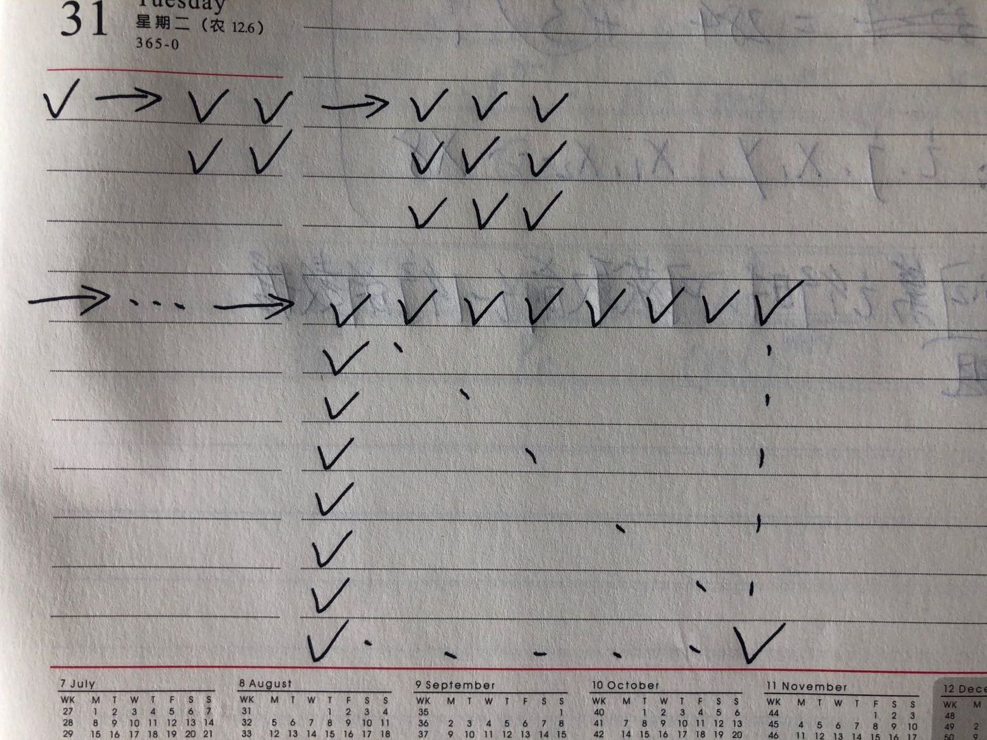

1. Consider 64 × 64 matrix

For a 64 × 64 matrix, 64 elements in each row occupy 8 cache blocks, so every 4 rows will occupy the entire cache.

1. Divide 64 × 64 matrix into 4 × 4 matrix. Although there is no intersection between matrix, the size of a block is 8 **int** data, we still don't make full use of every block after each load according to 4 × 4.
2. Divide 64 × 64 matrix into 8 × 8 matrix. Although we make full use of every block, there is intersection between matrix.

So can we combine these two methods?

**Solution:** Divide 64 × 64 matrix into 8 × 8 matrix. Recall how we deal with 32 × 32 matrix, we can deal with the diagonal between two 8 × 8 matrix in a similar way.

Consider the following case:

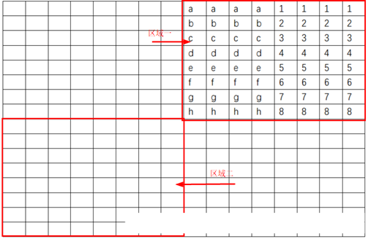

As the following figure shows, we store all the first four rows of area 1 into the first four rows of area 2. In this process, the first four columns of the first four rows have been transposed (yellow area), but the last four columns of the first four rows have not been put into the place where they should be put (blue area). However, in order not to access the same block any more, we take out the whole data at the same time and store it into the unused area.

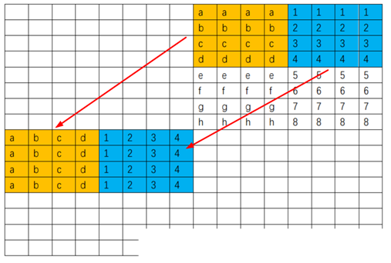

The first four columns of the last four rows are transposed row by row. The result after transposing is as follows:

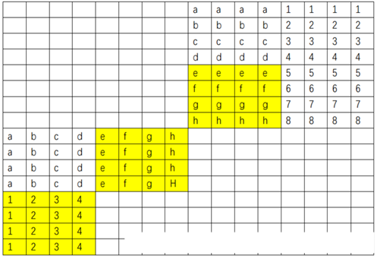

So far, the first four columns of the last four rows have been transposed. Finally, the last four columns of the last four rows have been transposed：

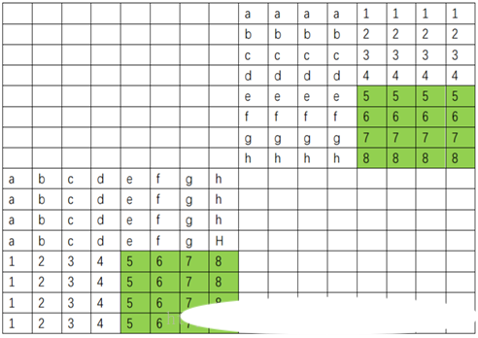

1. Consider 61 × 67 matrix

Because the scale of the matrix is 61 × 67, the “rule” is different from before. For the previous 32 × 32 and 64 × 64 matrix, because the number of elements in each line is exactly a multiple of 8, each line will occupy exactly an integer number of blocks, so it is easy to use this feature in the process of writing code. For the scale of 61 × 67, each line here no longer satisfies this rule. For example, the last five elements of the first row and the first three elements of the second are in the same block. Because of this feature, for the whole matrix, the block of each element is not easy to deal with.

So I try to divide 61 × 67 matrix into different K × K matrix and find that when K=17, the cache misses is minimum.

* + 1. Code

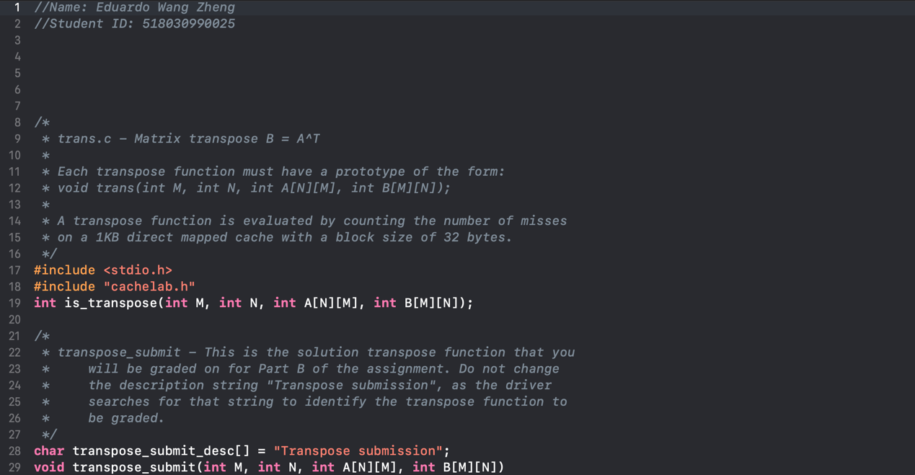

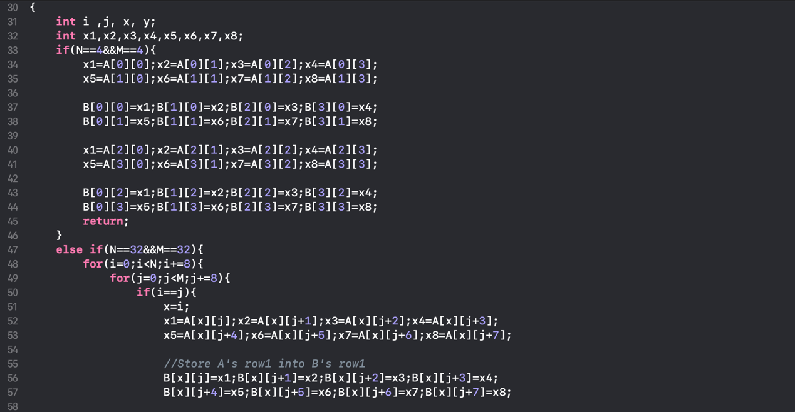

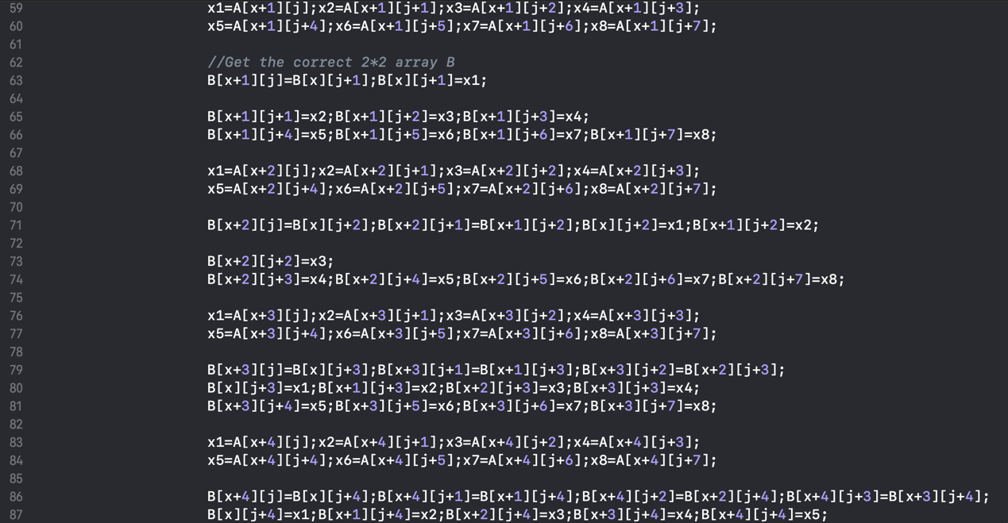

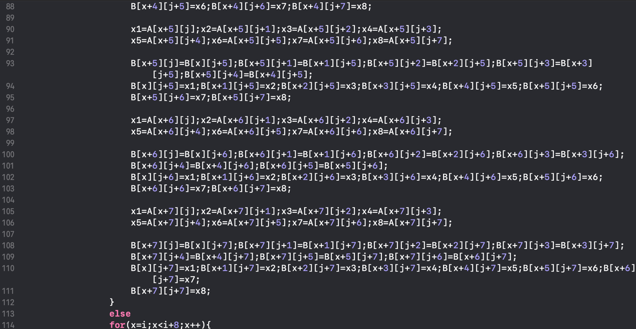

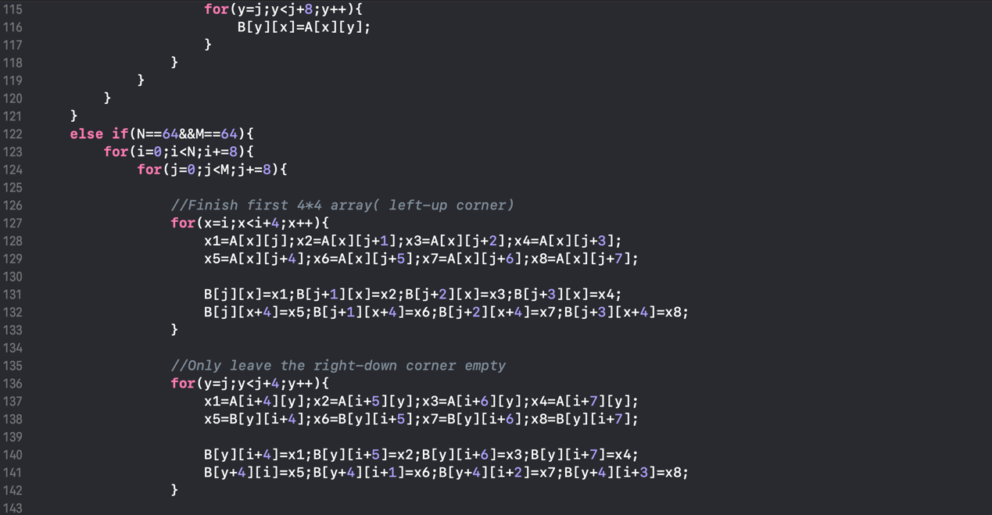

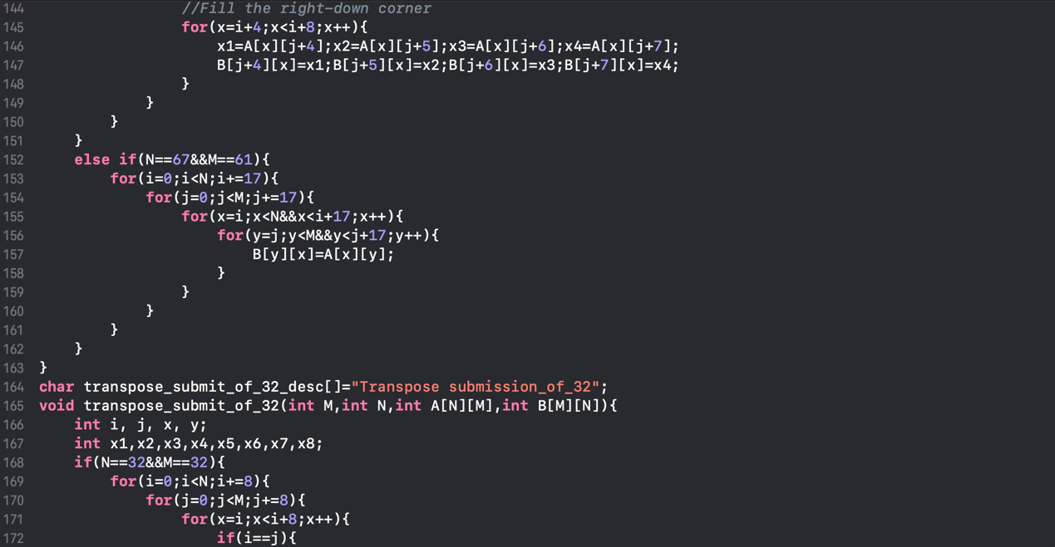

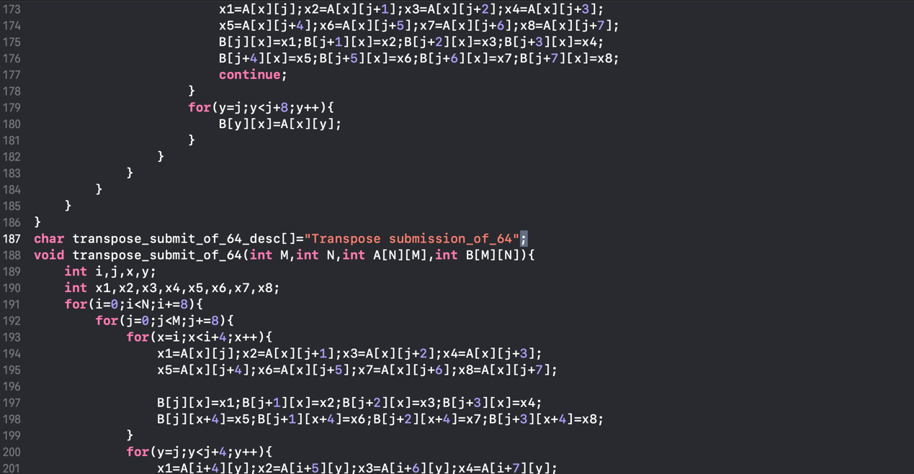

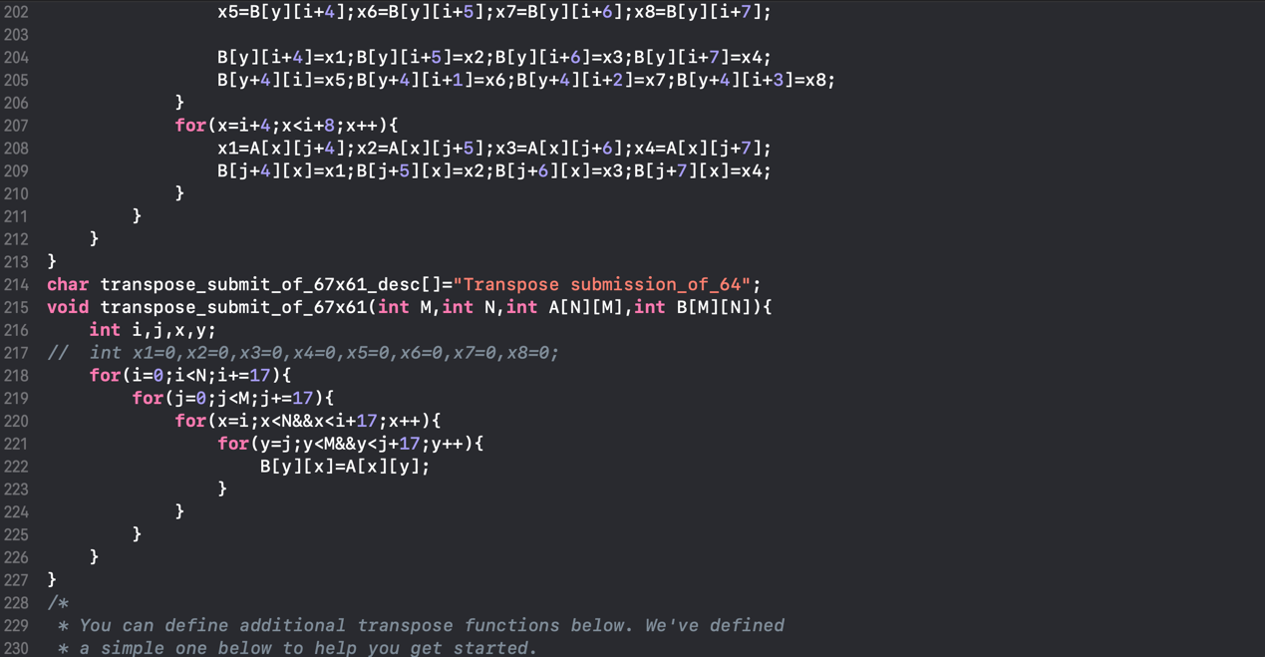

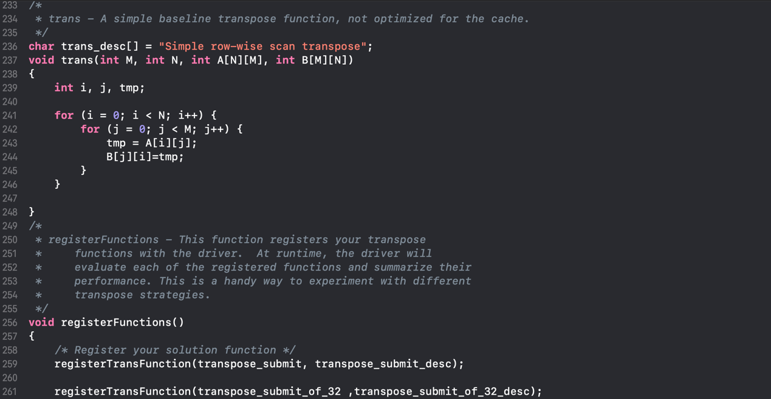

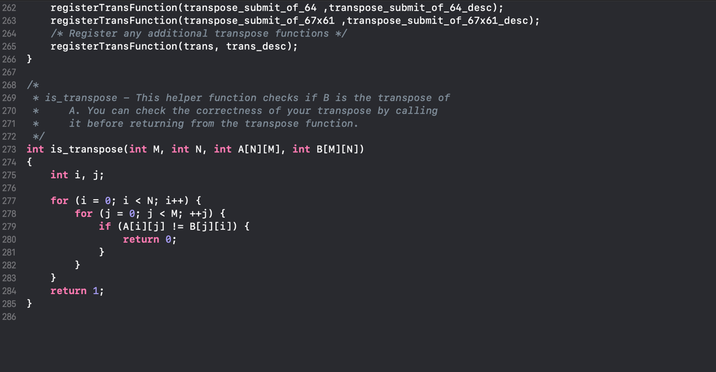

* + 1. Evaluation

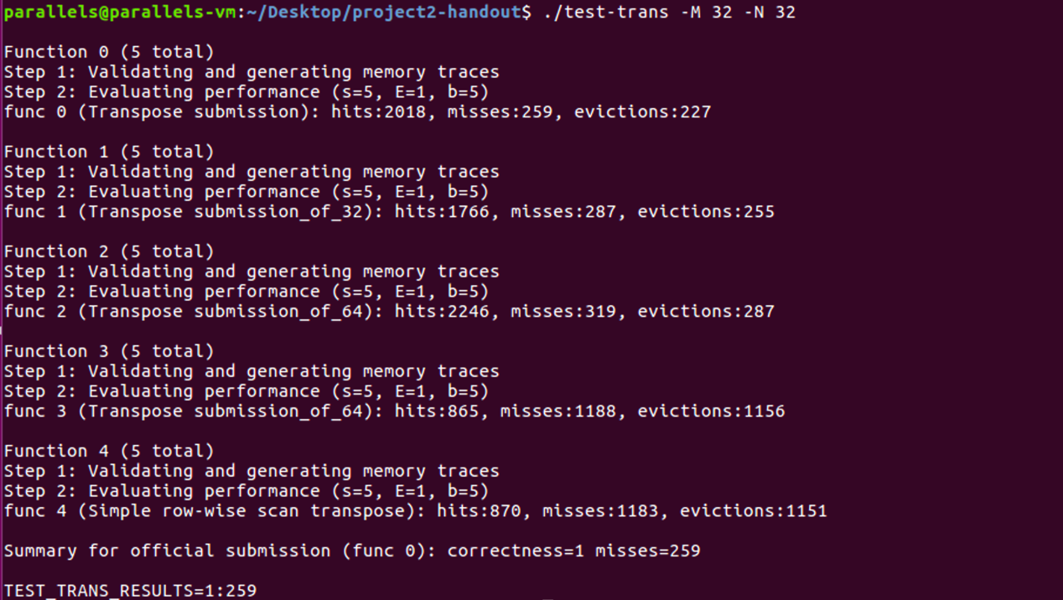

Figure 9 Test my registered transpose functions on a 32 × 32 matrix

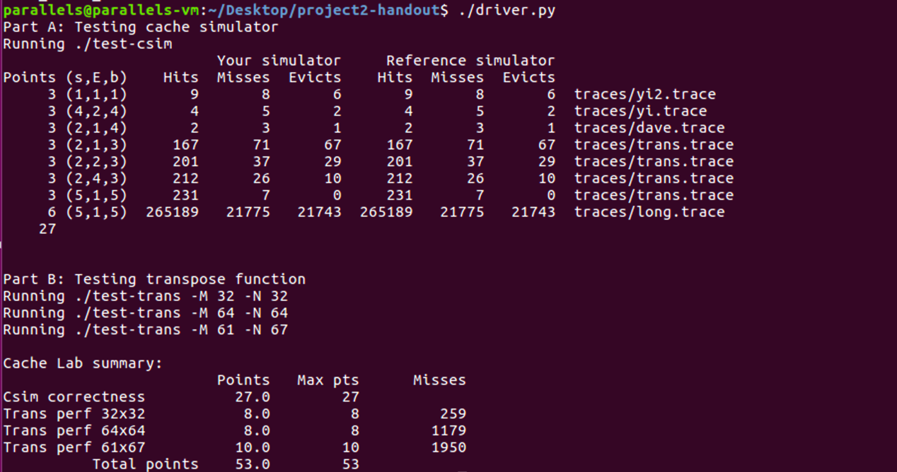

Figure 10 Test all cases

1. Conclusion
   1. Problems
2. **Problem:** There are too many **conflict misses** in the process of accessing two 4 × 4 matrix.

**Solution:** The reason behind is that the elements with the same subscript in array B and array A will map to the same cache block. As the first eight elements are in the same block, we can directly take out the eight elements, and then the block where the eight elements are no longer needed to access, so we can greatly reduce the number of conflict misses.

1. **Problem:** How to optimize the diagonal of the 32× 32 matrix(array B) ?

**Solution:** Store the elements in the first row of array a in the first row of array B, and then read the second row of array A and then access the second row of array B. In this way, I can deal with the rest of the lines in the same way.

1. **Problem:** When dealing with64 × 64 matrix, I find that if I divide 64 × 64 matrix into 4 × 4 matrix. Although there is no intersection between matrix, the size of a block is 8 **int** data, I still don't make full use of every block after each load If I divide 64 × 64 matrix into 8 × 8 matrix. Although we make full use of every block, there is intersection between matrix. So can we combine these two methods?

**Solution:** Divide 64 × 64 matrix into 8 × 8 matrix. Recall how we deal with 32 × 32 matrix, we can deal with the diagonal between two 8 × 8 matrix in a similar way.

* 1. Achievements

For part A, only one simulation process needs to be implemented, which is not very difficult on the whole. It is essential to have a clear idea for the whole simulation process, that is, what to do and how to do. After understanding each step, it is natural to write code. Through this part, I learned more about the processing of data input.

Part B is the challenging part. I start from a 4 × 4 example, analyze its hit and miss situations, and then extend to other situations. For a problem, we need to constantly think about how to solve, how to optimize, whether there is still the possibility of optimization and so on. In this series of thinking process, my ability of thinking and solving practical problems is improved.

Another gain is that this part enables me to have a deeper understanding of the details of cache work and master the relationship between blocking and the improvement of hit rate.

1. Reference
2. <https://blog.csdn.net/weixin_42294984/article/details/80738945?utm_medium=distribute.pc_relevant.none-task-blog-baidujs-5>
3. <https://blog.csdn.net/xiaolian_hust/article/details/80024777?utm_medium=distribute.pc_relevant.none-task-blog-baidujs-3>
4. <https://blog.csdn.net/ZhaoBuDaoFangXia/article/details/72626369?locationNum=6&fps=1>
5. <https://blog.csdn.net/mo_xiaojiang/article/details/72823238?utm_medium=distribute.pc_relevant.none-task-blog-BlogCommendFromMachineLearnPai2-28.nonecase&depth_1-utm_source=distribute.pc_relevant.none-task-blog-BlogCommendFromMachineLearnPai2-28.nonecase>
6. <https://blog.csdn.net/xbb224007/article/details/81103995?utm_medium=distribute.pc_relevant.none-task-blog-BlogCommendFromMachineLearnPai2-7.nonecase&depth_1-utm_source=distribute.pc_relevant.none-task-blog-BlogCommendFromMachineLearnPai2-7.nonecase>